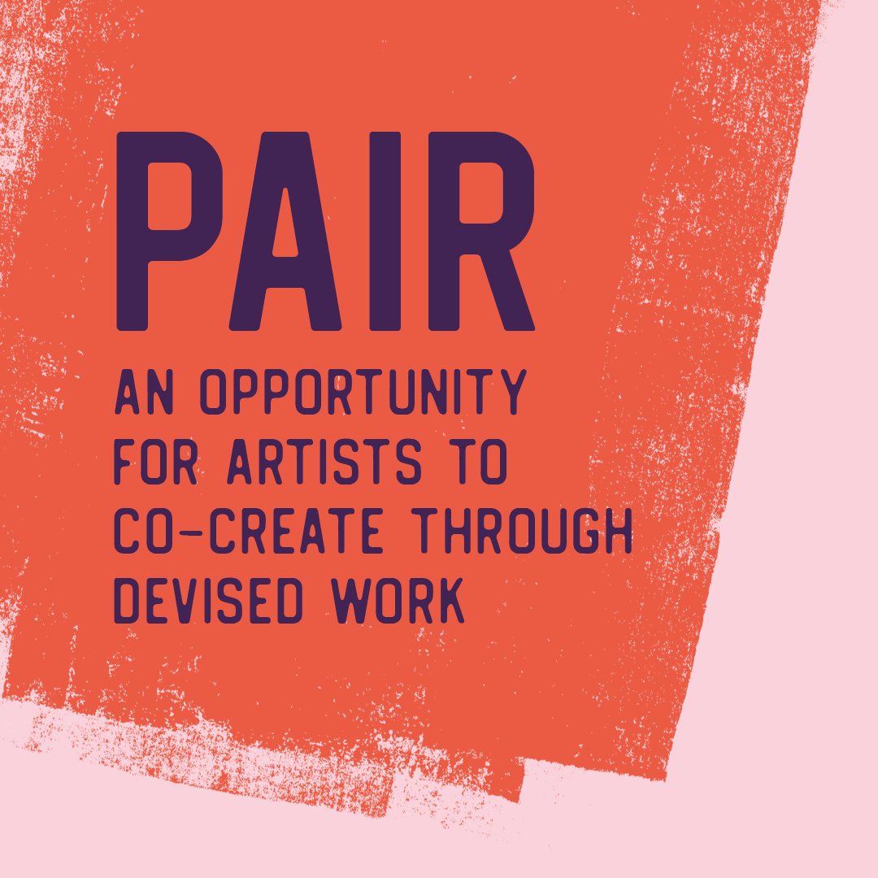
FAQs

What support will be given by Theatr Genedlaethol Cymru?
The Theatr Gen team will support every individual who takes part in the Pair project. We will coordinate training sessions and workshops with experts in the field of devising in order to develop your skills. Dr Rhiannon M. Williams, a freelance theatre worker, will be leading the project on our behalf, with support from Gavin Richards, our Assistant Producer; Melangell Dolma, our Creative Development Coordinator; and also from our Artistic Director. We will facilitate opportunities to develop a creative and professional relationship with Theatr Gen and S4C.
What is the timetable?
3 March 2022 | Period for declaring an interest opens
22 March 2022, 5pm | Closing date for declaring an interest  This can be done by completing a Declaring an Interest form in Welsh through Microsoft Forms, or you can submit a video application that is no more than 2 minutes in length to creu@theatr.com or via WhatsApp to 07908 439417, and it will also be necessary to submit the Equalities Monitoring Form.
25 March 2022 | Drawing up a shortlist  The shortlisted candidates will hear from us by the end of March with an invitation to submit a full application. We will supply an application form, together with details of how to submit a video application. We will also offer a fee of £50 to all those on the shortlist to enable them to compile a fuller application.
28 March 2022 | If you are to be invited to submit an application, you will be informed by this date
18 April 2022, 12 noon | Closing date for full applications
21 and/or 22 April 2022 | On-line interviews to be held
25 April 2022 | Offering an opportunity for up to 12 successful applicants  Applicants will need to be available during the following periods:  16 May 2022 to 20 May 2022 for Tanio’r Pair devising sessions  Week commencing 13 June for an on-line meeting  One of the following weeks:  27 June 2022  4 July 2022  11 July 2022
September 2022 | A meeting with partners to discuss ideas
October 2022 | Appraisal meeting

Can I include a CV as an additional attachment when declaring an interest to take part in Pair?
If you wish, you are welcome to attach a CV or submit your CV by video, but you are not under any obligation to do so.

What are the terms offered?
If you are invited to submit a full application, you will be paid £50.
If you are offered an opportunity to join the project, each artist will receive £1,350 for 1 week (i.e. 5 days) @ £600 x 2 weeks and 1 day @ £150, a total of eleven days.
Up to three persons will be nominated by the group to work a further day formalising the outline/pitch and sharing it with the other members of the group by e-mail. An additional sum of £150 will be paid to these three, making a total of £1,500 for twelve days’ work.
Where appropriate, entry costs and travel, accommodation and subsistence expenses will be paid.

What if I’m not available on the dates listed?
Some of the dates listed in the above timetable are flexible, and not being available on occasional days does not rule you out from taking part in the project. If you would like to discuss any issues regarding the dates or your availability, please contact Gavin Richards by email at gavin.richards@theatr.com

What is the nature of the project?
The aim of the project is:
- To develop artists in examining devised / collaborative ways of creating new work
- To discover stories and a framework for creative projects, to be presented to Theatr Gen and S4C, and which could lead to new theatre or multi-platform productions
- To introduce the idea of writing rooms / creative room / collaborative creative space as a way of working
- To train theatre practitioners and writers to use research and development techniques that involve more cooperation with other artists (from various disciplines) when creating, and spending less time sitting alone to create (e.g. in front of a computer)
- To create new contacts between artists, and between artists and Theatr Gen and S4C
- To develop skills in writing and creating by means of devising
- To inspire artists to create new work in a way that is experimental or different from their usual method

Are there any restrictions?
Pair is open to any artist in Wales who is over 18 years old, who can speak Welsh or is eager to increase their confidence in using Welsh in their work, and who is a freelance cultural worker.
The development of any creative ideas must conform to the current Covid-19 advice and guidelines issued by the Welsh Government and Public Health Wales relating to social distancing, or any new lockdown periods both nationally and locally.
It will be necessary to keep within the budget for the project, which will be managed by Theatr Gen.

I have never worked in the arts. Am I still able to apply?
We welcome applications from anyone who has an interest in working in the arts, or an ambition to do so, in addition to those who already have experience in the sector. We welcome both emerging artists at the start of their careers, and experienced artists. This project is open to creative disciplines including (but not confined to); actors, playwrights, writers, storytellers, drama directors of all kinds, musicians, composers, dancers, choreographers, set and costume designers, sound and lighting designers, video artists and more.

I have never done any devising work, but I’m very interested in the field. Am I eligible to apply?
You can apply if you believe that you would enjoy working creatively with others. We will ensure that specific guidelines are in place to facilitate your collaboration in group working, and we will offer support and specific training throughout the period of your commitment with us. You are welcome to get in touch with us if you would like a chat before declaring an interest, so that we can explain the project to you in more detail.
I’m not confident in writing/speaking Welsh. Can I express an interest?
Yes of course. You should submit your declaration of interest and a full application in Welsh, and it isexpected that the work to be developed is mainly in Welsh, but we can support you with this. Developing confidence in using the Welsh language in the arts is very important to us as a company.
I’ve got a brilliant idea, but I’ve never developed my own idea before.
No problem. The aim of this project is to form a group to work in cooperation with you to develop ideas for theatre production.

